AI ASSISTED CODING
Task 1:
Question :
Zero-Shot Prompting (Palindrome Number Program)
Write a zero-shot prompt (without providing any examples) to generate a Python function that checks whether a given number is a palindrome.
Task:
- Record the AI-generated code.
- Test the code with multiple inputs.
Identify any logical errors or missing edge-case handling
Prompt:
Give python code to check wheather the number is palindrom are not
Code :
number = input("Enter a number: ").strip()

if number == number[::-1]:
print("The number is a palindrome.")
else:
print("The number is not a palindrome.")

output:
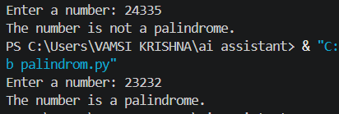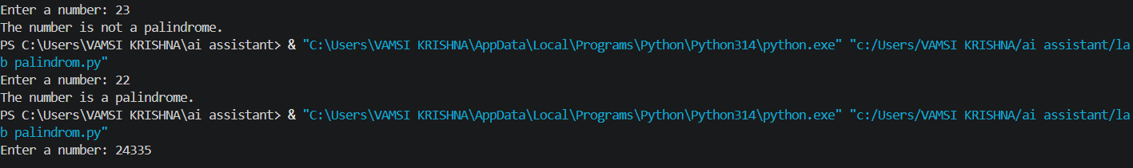

Task 2 :
Question:
One-Shot Prompting (Factorial Calculation)
Write a one-shot prompt by providing one input-output example and ask the AI to generate a Python function to compute the factorial of a given number.
Example:
Input: 5 → Output: 120
Task:
- Compare the generated code with a zero-shot solution.
Examine improvements in clarity and correctness.
Prompt:
give a python code to calculate factorial of a number.
Code:
def factorial(number):
if number < 0:
raise ValueError("Factorial is not defined for negative numbers")

result = 1
for value in range(2, number + 1):
result *= value
return result

number = int(input("Enter a non-negative integer: "))
print(f"Factorial of {number} is {factorial(number)}")
Output:
Enter a non-negative integer: 4
Factorial of 4 is 24
Enter a non-negative integer: 23
Factorial of 23 is 25852016738884976640000
Enter a non-negative integer: 9
Factorial of 9 is 362880

Task 3:
Question:
Few-Shot Prompting (Armstrong Number Check)
Write a few-shot prompt by providing multiple input-output examples to guide the AI in generating a Python function to check whether a given number is an Armstrong number.
Examples:
- Input: 153 → Output: Armstrong Number
- Input: 370 → Output: Armstrong Number
- Input: 123 → Output: Not an Armstrong Number
Task:
- Analyze how multiple examples influence code structure and accuracy.
Test the function with boundary values and invalid inputs
Prompt:
Give a python code to check wheather the number is Armstrong Number are not
Code:
number = int(input("Enter a number: "))
digits = str(abs(number))
power = len(digits)
total = sum(int(digit) ** power for digit in digits)

if number >= 0 and total == number:
print("Armstrong number")
else:
print("Not an Armstrong number")
Output:
Enter a number: 153
Armstrong number
Enter a number: 143
Not an Armstrong number
Enter a number: 9474
Armstrong number

Task 4:
Question:
Context-Managed Prompting (Optimized Number Classification)
Design a context-managed prompt with clear instructions and constraints to generate an optimized Python program that classifies a number as prime, composite, or neither.
Task:
- Ensure proper input validation.
- Optimize the logic for efficiency.
- Compare the output with earlier prompting strategies.
Prompt:
give python code to classification of optimized number
Code:
"""Classify an integer efficiently."""

from math import isqrt

def classify_number(number: int) -> list[str]:
"""Return useful classifications for *number* in O(sqrt(number)) time."""
if not isinstance(number, int):
raise TypeError("number must be an integer")

result = []
result.append("zero" if number == 0 else "positive" if number > 0 else "negative")
result.append("even" if number % 2 == 0 else "odd")

absolute = abs(number)
if absolute > 1:
result.append("prime" if all(absolute % divisor for divisor in range(2, isqrt(absolute) + 1)) else "composite")
else:
result.append("neither prime nor composite")

return result

Output:
Enter an integer: 12
positive, even, composite
Enter an integer: -45
negative, odd, composite

Task 5:
Question:
Zero-Shot Prompting (Perfect Number Check)
Write a zero-shot prompt (without providing any examples) to generate a Python function that checks whether a given number is a perfect number.
Task:
- Record the AI-generated code.
- Test the program with multiple inputs.
- Identify any missing conditions or inefficiencies in the logic.
Prompt:
Give a python code to check wheather the number is perfect number are not
Code:
number = int(input("Enter a number: "))

if number > 1:
divisor_sum = sum(divisor for divisor in range(1, number) if number % divisor == 0)

if divisor_sum == number:
print(f"{number} is a perfect number.")
else:
print(f"{number} is not a perfect number.")
else:
print(f"{number} is not a perfect number.")

Output:
Enter a number: 6
6 is a perfect number.
Enter a number: 23
23 is not a perfect number.

